### Experiment – No-9

|  |  |  |
| --- | --- | --- |
| Objective: Program to find the sum of digits of the entered number. | | |
| Scheduled Date | Compiled Date | Submission Date |
| 09-Jan-2021 | 09-Jan-2021 | 10-Jan-2021 |

### Program : A Program to find the sum of digits of the entered number.

### Algorithm

Step 1: Start

Step 2: Declare variable n,sum,rem

Step 3: Read the value of n.

Step 4: Apply condition

While(n>0)

Step 5: Given:

rem = n%10

sum = sum+rem

n=n/10

Step 6: Print sum.

Step 7: Exit

### 

**Program**

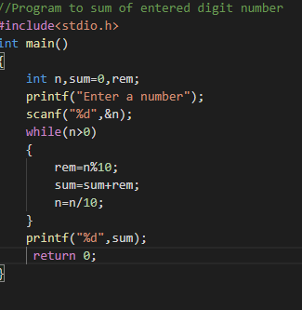

### Output Screen

### C:\Users\WIN10\Pictures\ss13.png